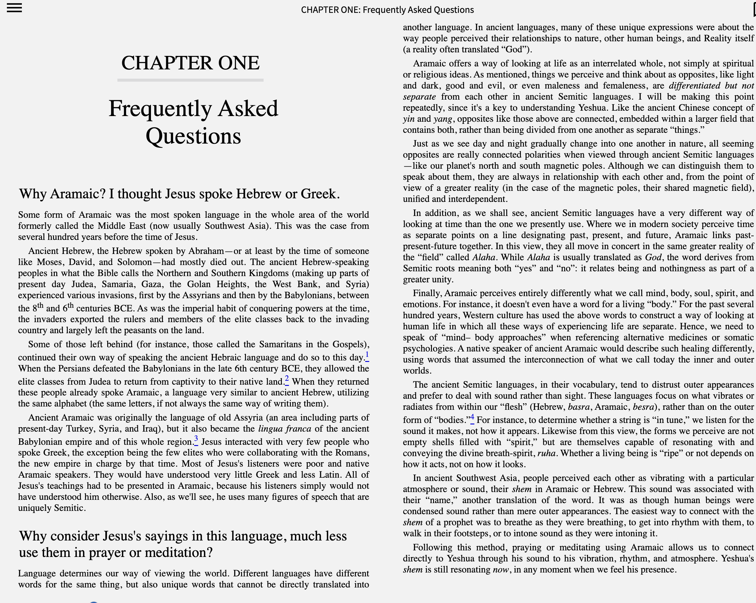

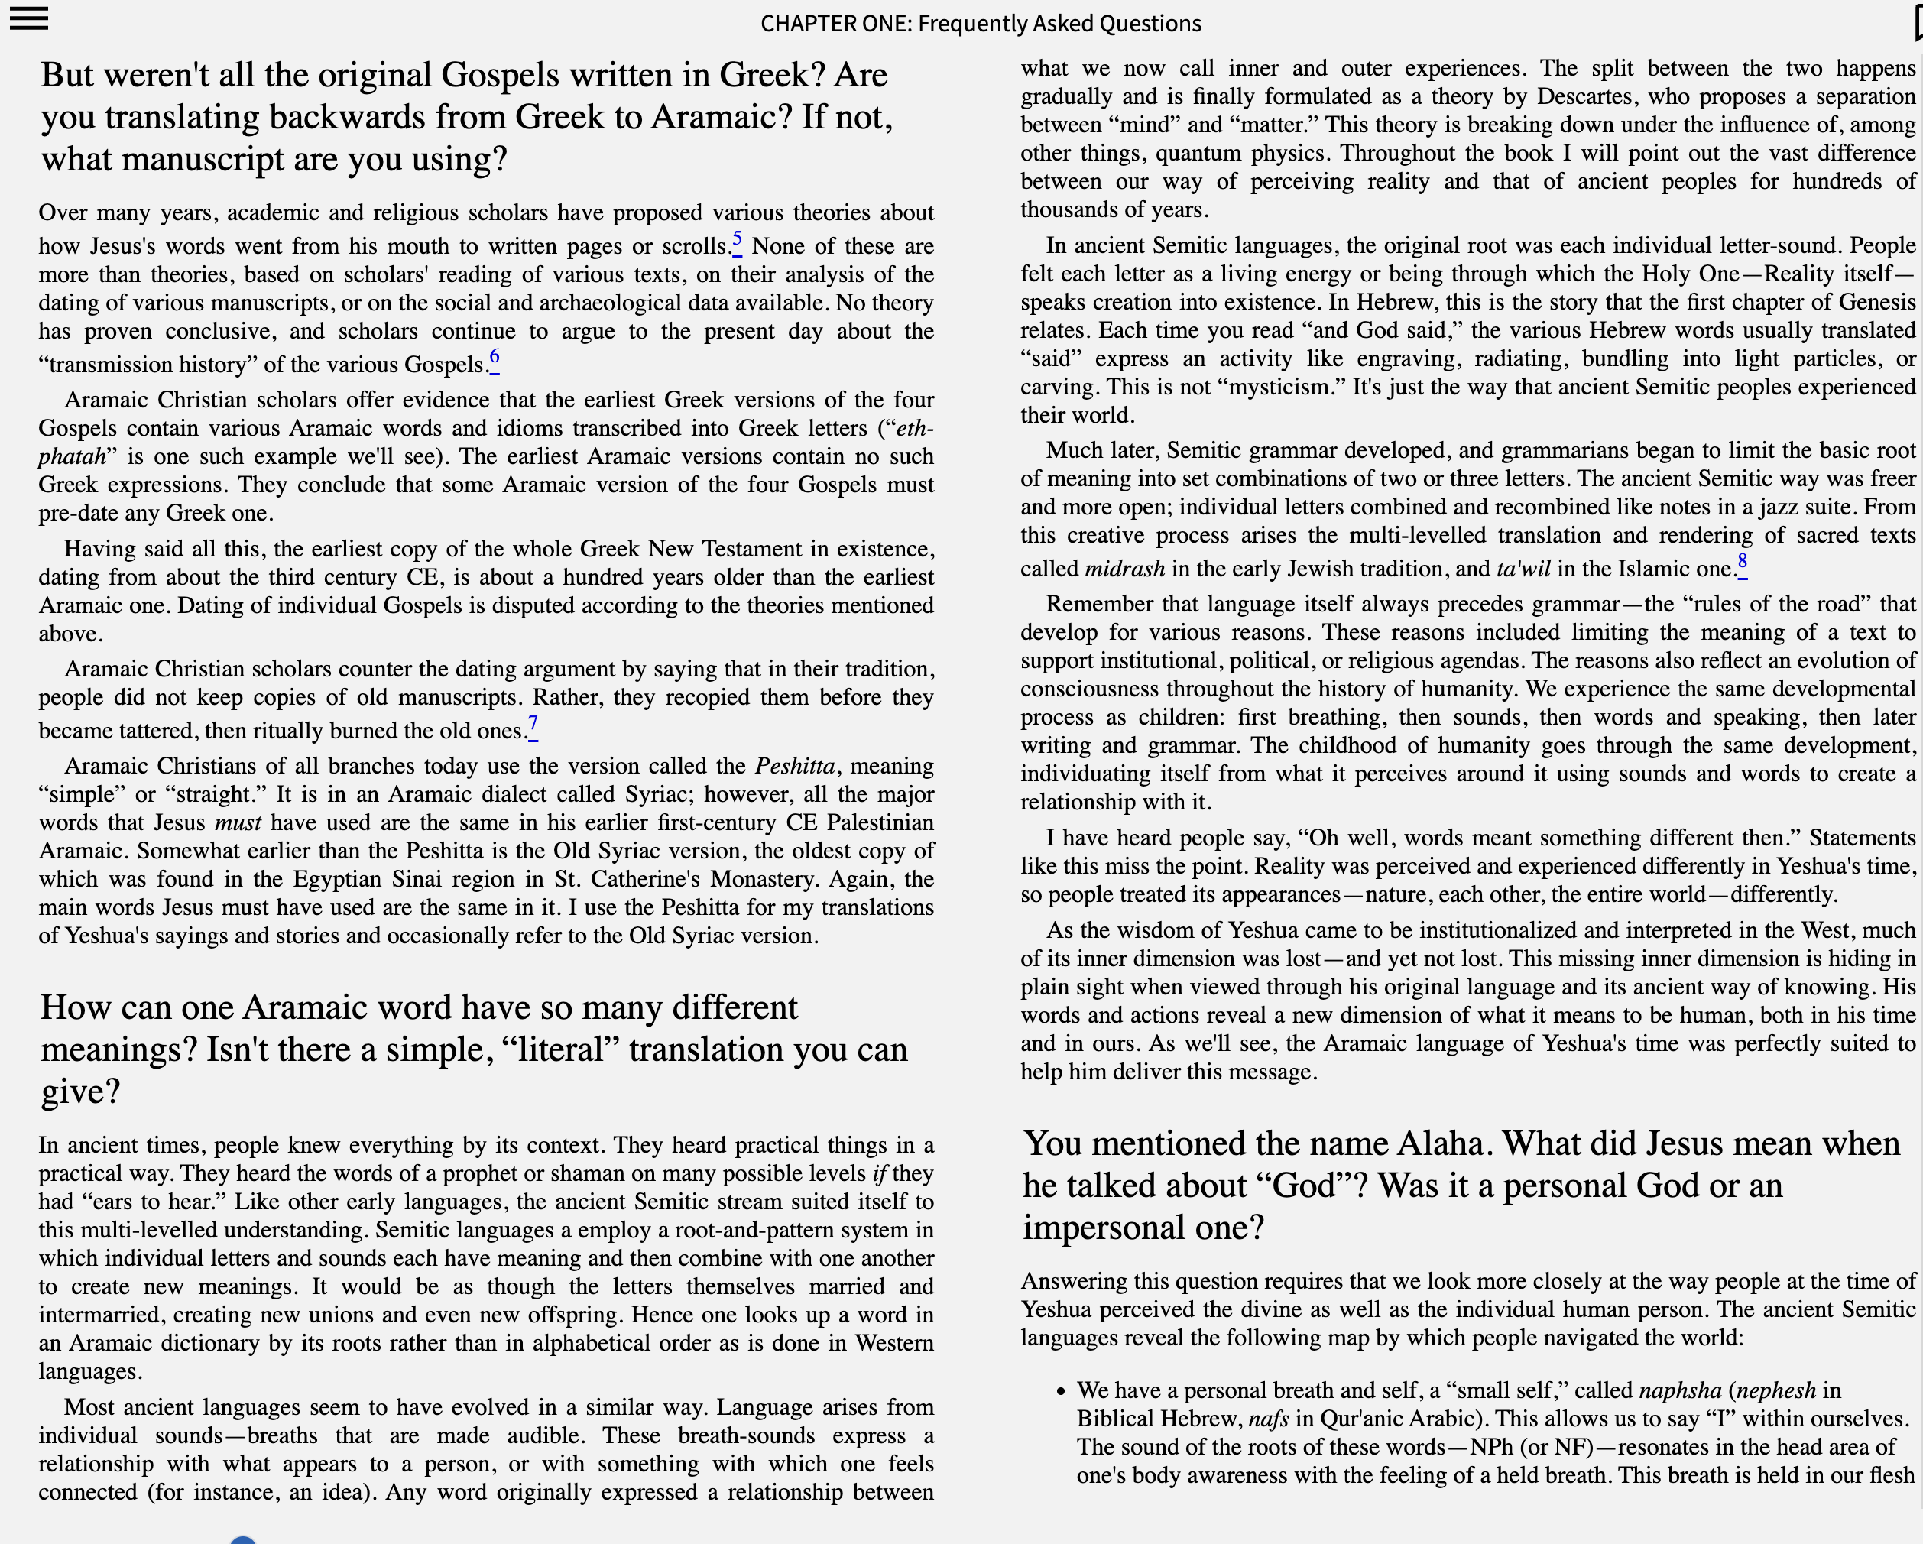
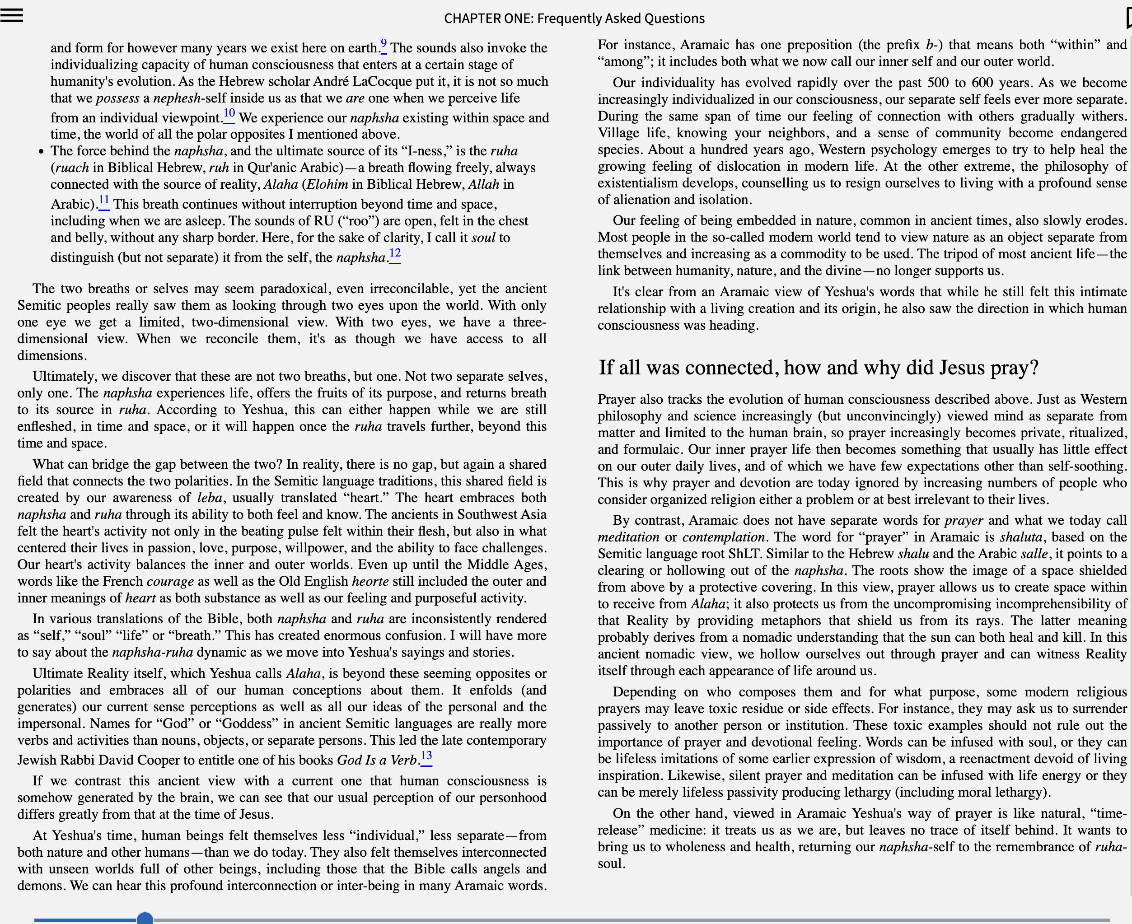
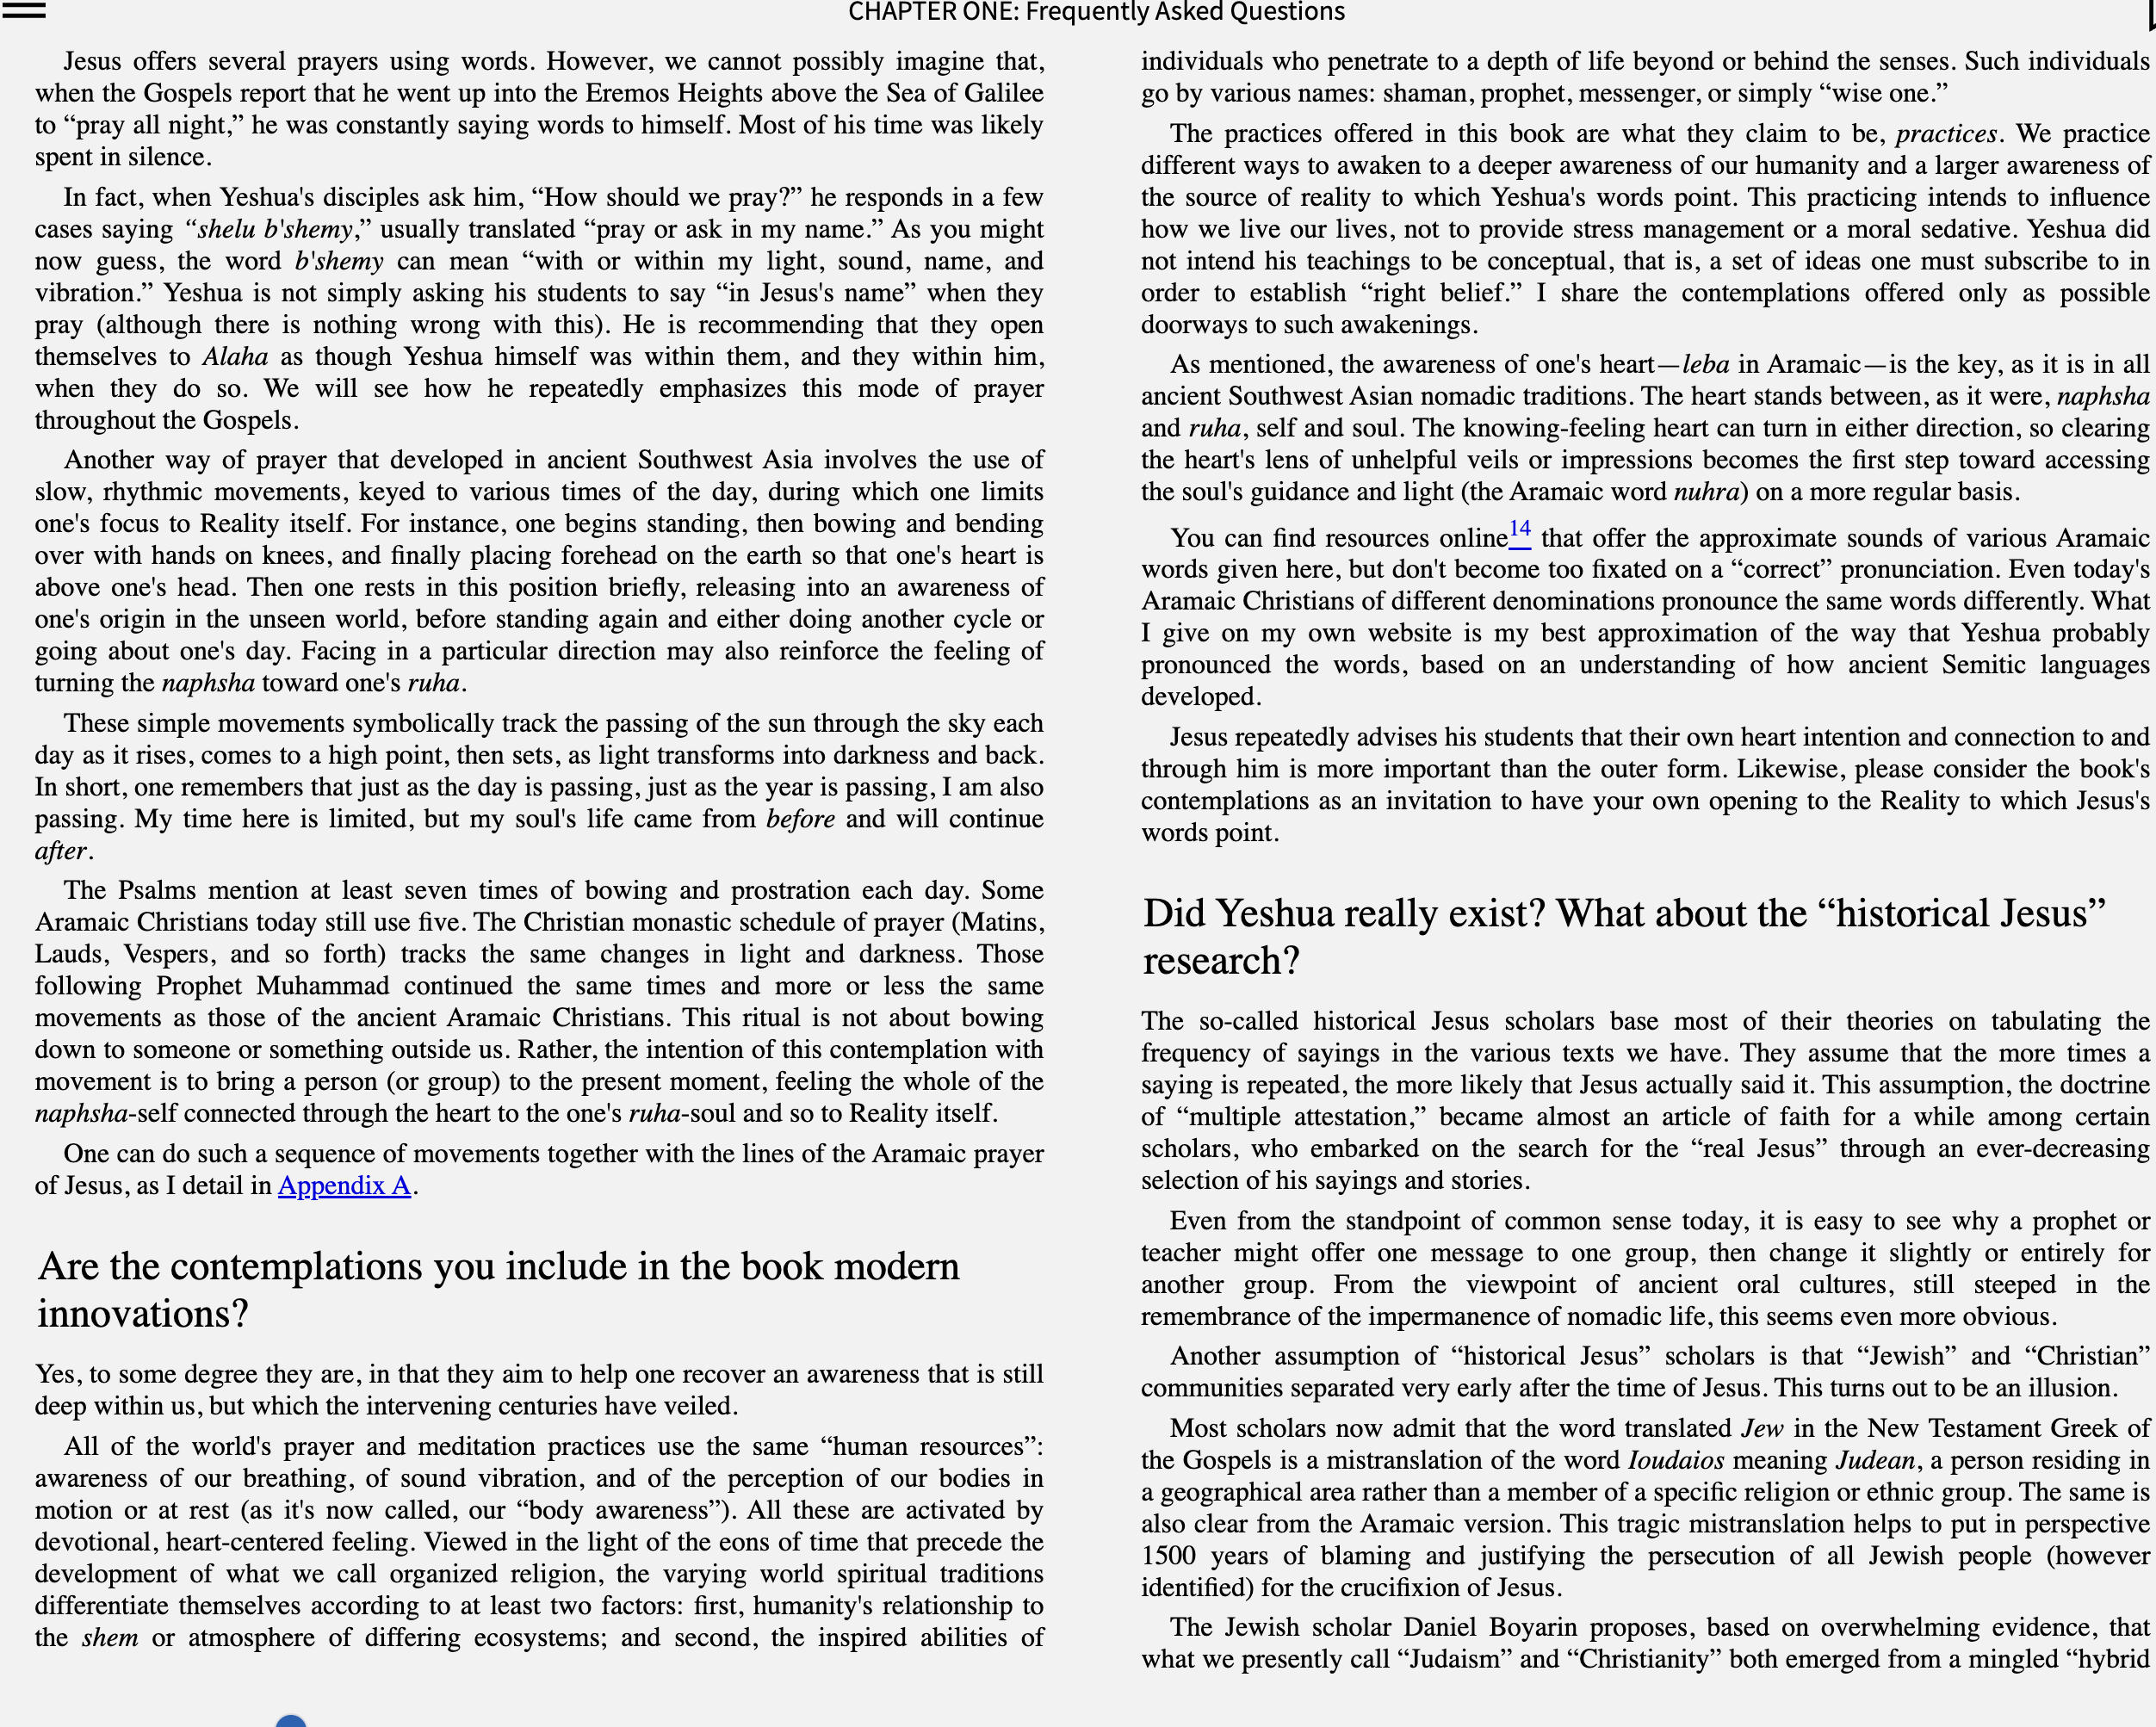
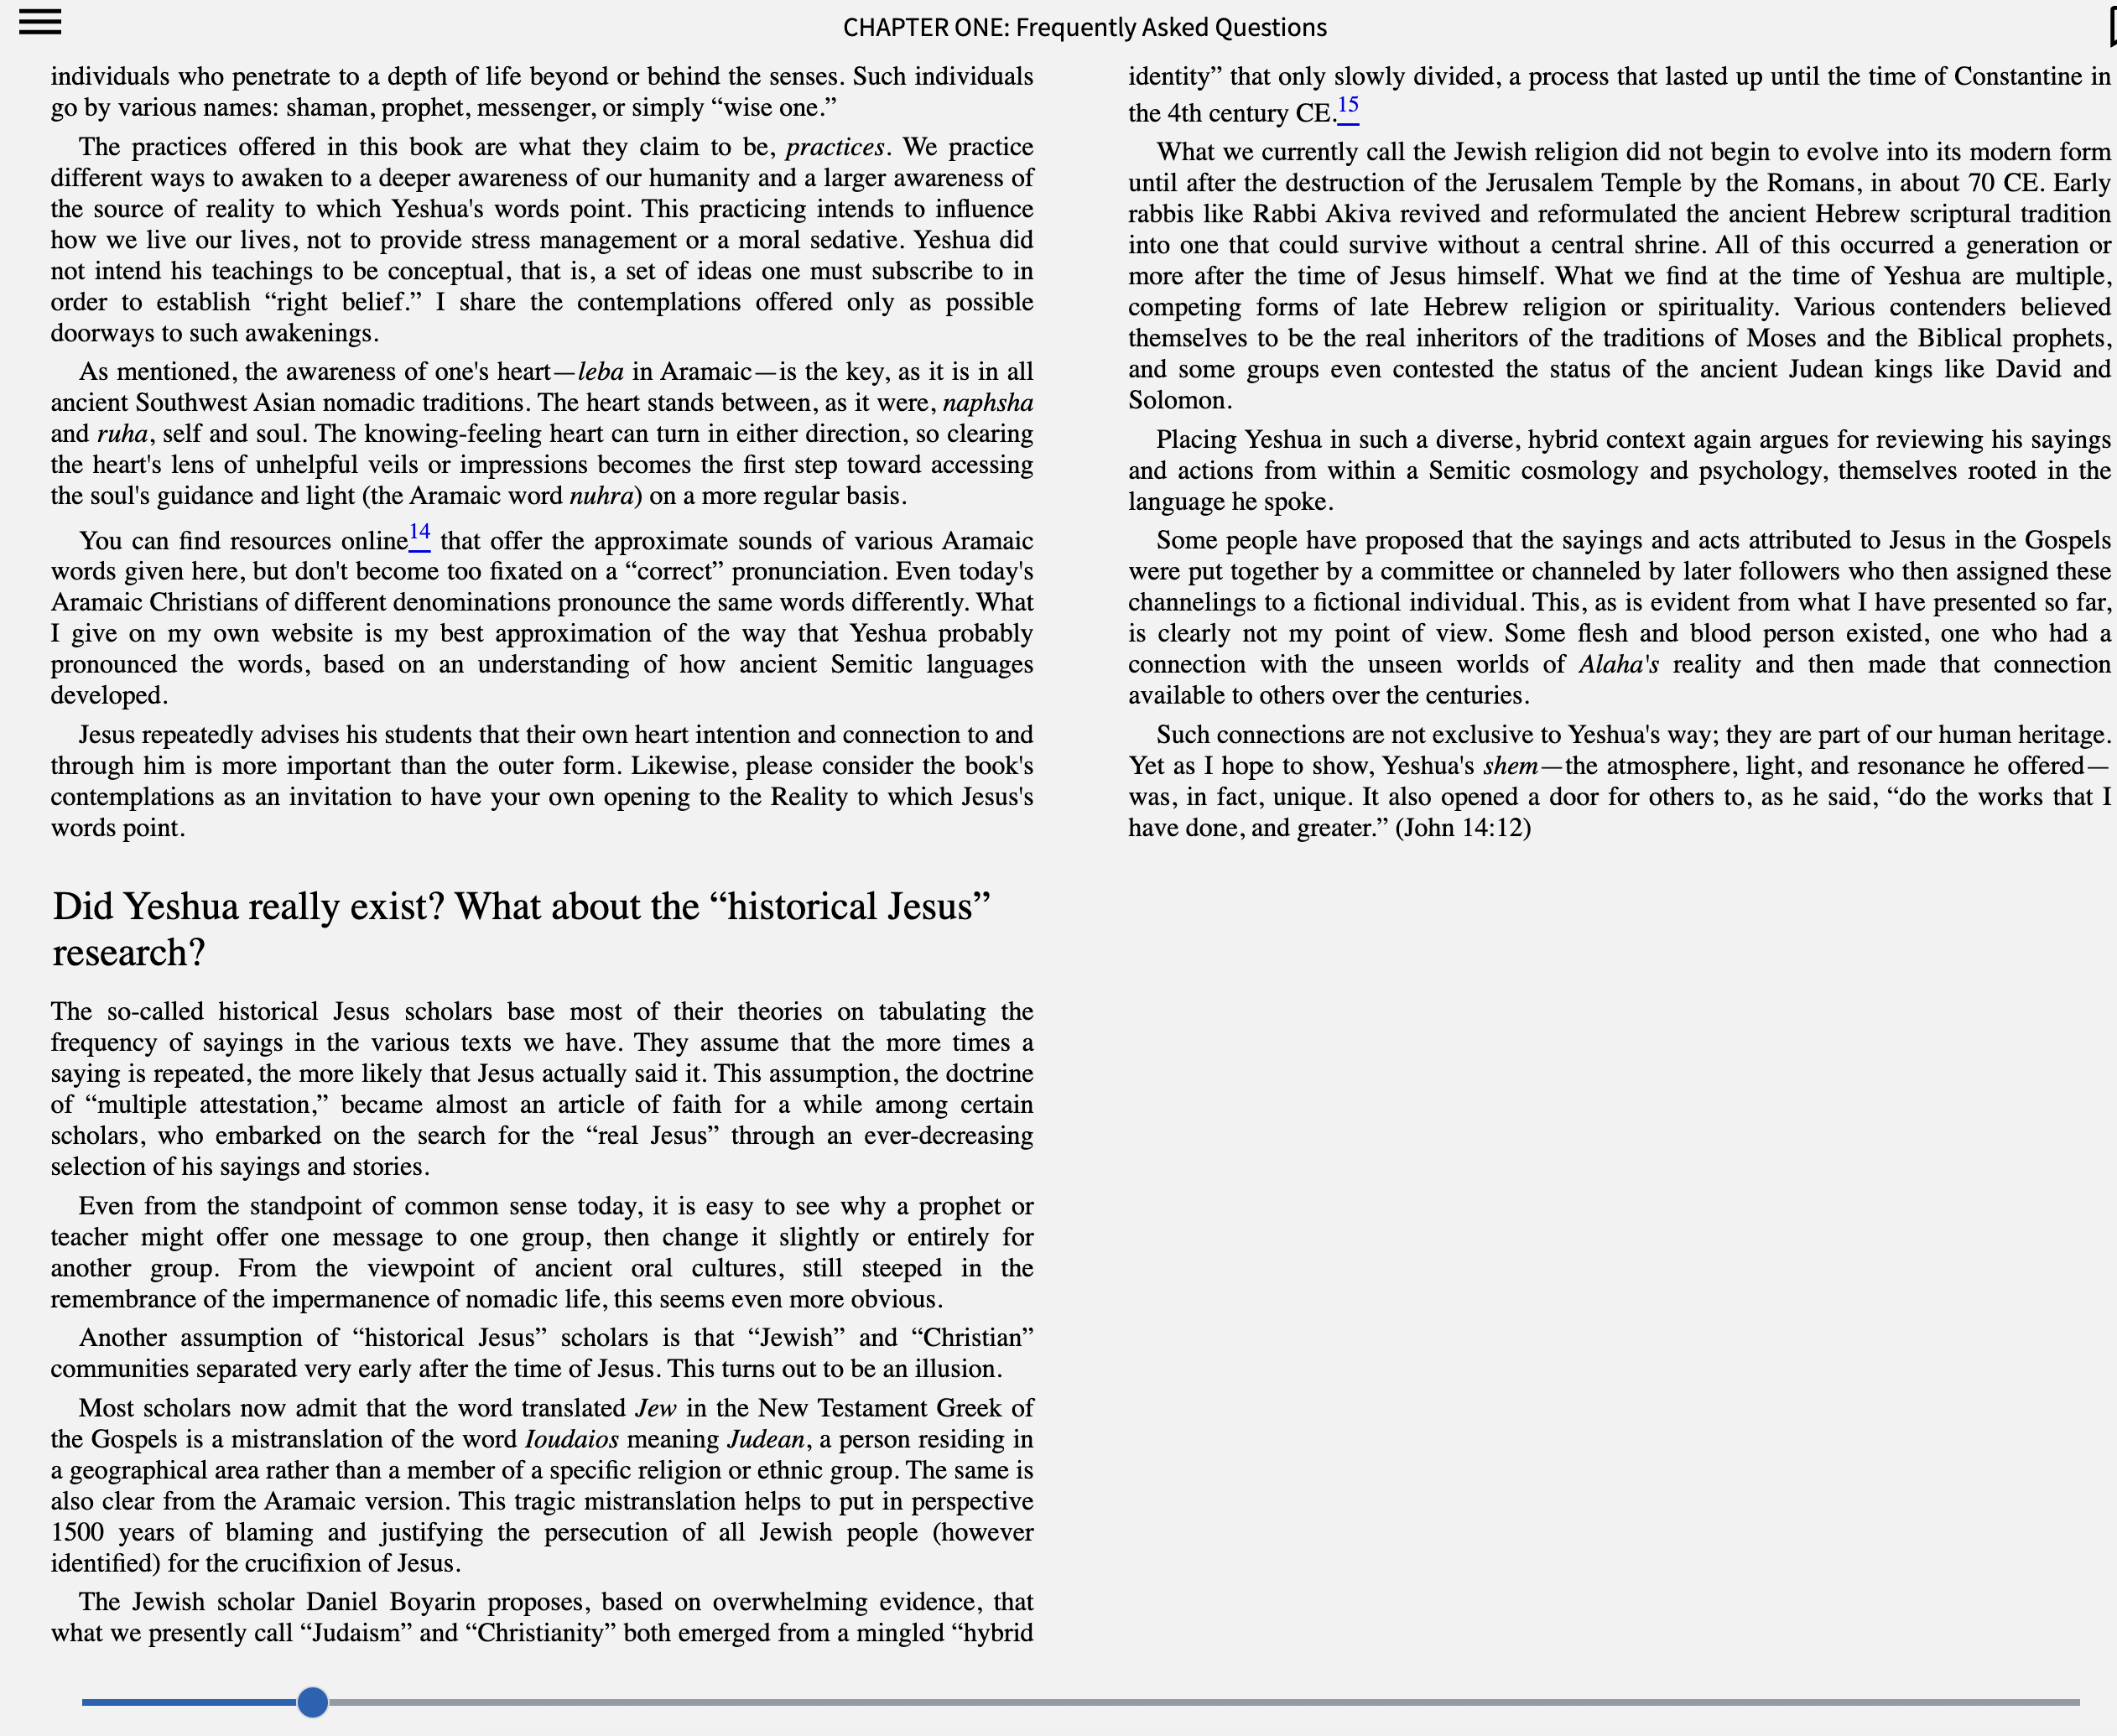

Chapter One from Revelations of the Aramaic Jesus by Neil Douglas-Klotz
- See, for instance, the website of the Israelite Samaritan Information Service: www.israelite-samaritans.com.
- Check online for the history of these various empires, which is outside the scope of this book.

