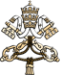 |  |  |  | 
Home > Bulletin > Pubblico > 2016 > 06
Mary Magdalene, apostle of the apostles, 10.06.2016

Vatican City, 10 June 2016 – As expressly wished by the Holy Father, the Congregation for Divine Worship and the Discipline of the Sacraments has published a new decree, dated 3 June 2016, Solemnity of the Sacred Heart of Jesus, by which the celebration of St. Mary Magdalene, currently obligatory memory, will be elevated in the general calendar to the level of a feast day.
Archbishop Arthur Roche, secretary of the Congregation for Divine Worship and the Discipline of the Sacraments, explains the meaning of the decree that will enable Mary Magdalene to be "celebrated" liturgically like the rest of the apostles. "The decision is situated in the current ecclesial context, which calls upon us to reflect more deeply on the dignity of women, the new evangelisation and the greatness of the mystery of divine mercy. It was St. John Paul II who dedicated great attention not only to the importance of women in the very mission of Christ and the Church, but also, and with special emphasis, to the peculiar function of St. Mary Magdalene as the first witness of the Risen Christ and the first messenger who announced to the apostles the resurrection of the Lord. This importance remains in today's Church – as shown by the current commitment to a new evangelisation – which seeks to welcome, without distinction, men and women of any race, people, language and nation, to proclaim to them the good news of the Gospel of Jesus Christ, to accompany them on their earthly pilgrimage and to offer them the wonders of God's salvation. St. Mary Magdalene is an example of true and authentic evangelisation, that is, an evangeliser who proclaims the joyful central message of Easter."
"The Holy Father Francis has taken this decision precisely in the context of the Jubilee of Mercy to stress the importance of this women, who shows great love for Christ and was very dear to Christ, as confirmed by Rabano Mauro ("dilectrix Christi et Christo plurimum dilecta": De vita beate Mariae magdalenae, Prologus) and St. Anselm of Canterbury ("electa dilectrix et dilecta Electrix Dei", Oratio a LXXIII Sanctam Mariam Magdalenam). It is certain that the Christian tradition in the West, especially after St. Gregory the Great, identifies as the same person who poured perfume in the house of Simon the Pharisee, and the sister of Lazarus and Martha. This interpretation continued to influence the western ecclesiastical writers, Christian art and liturgical texts relating to the Saint. The Bollandists widely discussed the problem of the identification of the three women and prepared the way for the liturgical reform of the Roman Calendar. With the implementation of the reform, the tests of the Roman Missal, the Liturgy of the Hours and the Martyrologium Romanum, reference is made to Mary of Magdala. It is certain that Mary Magdalene formed part of the group of Jesus' disciples, that she followed Him to the foot of the cross and in the garden in which she found the tomb, she was the first 'testis divinae misericordiae', as St. Gregory the Great affirmed. The Gospel of John says that Mary Magdalene wept, as she had not found the body of the Lord, and Jesus had mercy on her, allowing Himself to be recognised as the Master and transforming her tears into Paschal joy."
The archbishop took the opportunity to highlight two ideas inherent in the biblical and liturgical texts of the new feast, which may contribute to a better understanding of the current importance of a saint such as Mary Magdalene.
"On the one hand, she has the honour of being the 'prima testis' to the resurrection of the Lord, the first to see the empty tomb and the first to hear the truth of His resurrection. Christ has a special consideration and mercy for this woman, who shows her love for Him, looking for Him in the garden with anguish and suffering, with 'lacrimas humilitatis', as St. Anselm says in the aforementioned prayer. In this sense, I would like to show the difference between the two women present in the garden of Paradise, and in the garden of the Resurrection. The first disseminates death where there was life, and the second proclaims Life from a tomb, the place of death. … Likewise, it is in the garden of resurrection that the Lord says to Mary Magdalene, 'Noli me tangere'. It is an invitation not only to Mary, but also to all the Church, to enter into an experience of faith that overcomes any materialistic appropriation or human understanding of the divine mystery. It has ecclesial importance! It is a good lesson for every disciple of Jesus: do not seek human securities and worldly honours, but faith in the Living and Risen Christ."
"Precisely since she was an eyewitness to the Risen Christ, she was also the first to testify before the apostles. She fulfils the mandate the Risen Christ gives her: 'go to my brothers and say to them … Mary Magdalene went and announced to the disciples, “I have seen the Lord”—and that he had said these things to her'. In this way she becomes, as is already known, an evangelist, or rather a messenger who announces the good news of the resurrection of the Lord; or, as Rabano Mauro and St. Thomas Aquinas said, 'apostolorum apostola', as she announces to the apostles what they in turn will announce to all the world. The Angelic Doctor is right to apply this term to Mary Magdalene: she is the witness to the Risen Christ and announces the message of the resurrection of the Lord, like the other apostles. Therefore it is right that the liturgical celebration of this woman should have the same level of festivity given to the apostles in the General Roman Calendar, and that the special mission of this woman be highlighted, as an example and model to every woman in the Church", concluded Archbishop Roche.

- To the World Communion of Reformed Churches: an ecumenism that unites theological dialogue with a shared mission of evangelisation and service
- The liturgical memory of Mary Magdalene becomes a feast, like that of the other apostles
- Holy See Press Office communiqué
- Audiences

For those who are interested in some additional Mary Magadelene threads:
Cynthia’s Wisdom Waypoint community has some articles you can find here

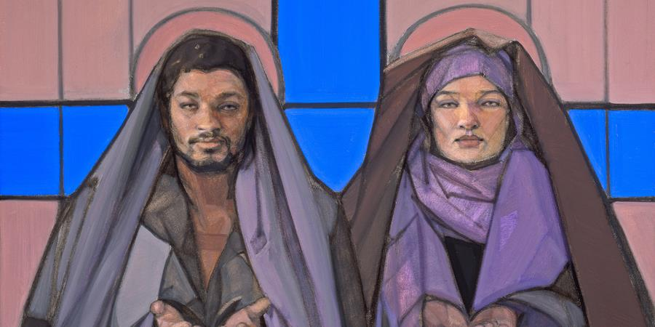

Summary: Week Twenty-nine

Mary Magdalene

July 19 - July 24, 2020

Mary Magdalene is the icon and archetype of love itself—needed, given, received, and passed on. . . . Jesus’ appearance to her first and alone is the clear affirmation of the wonderful message that we do not need to be perfect to be the beloved of Jesus and God. (Sunday)
Like myself, a great many Christians have absorbed most of what they know about Mary Magdalene through the dual filters of tradition and the liturgy, which inevitably direct our attention toward certain aspects of the story at the expense of others. —Cynthia Bourgeault (Monday)
What if, instead of emphasizing that Jesus died alone and rejected, we reinforced that one stood by him and did not leave? —Cynthia Bourgeault (Tuesday)
Mary Magdalene and the other women were the first witnesses to the resurrection because they remained present for the entire process. (Wednesday)
Great love is both very attached (“passionate”) and yet very detached at the same time. It is love but not addiction. (Thursday)
I painted Mary Magdalene and Christ seated side by side as visionaries and spiritual teachers with their hands open in the universal gesture of prayer—gifts offered and received—as icons of the sacred. —Janet McKenzie (Friday)

Practice: Bride and Beloved
Today’s contemplative practice is inspired by the life of Mary Magdalene and her role as an icon and archetype for the full partnership of women in the divine. Psychotherapist Joan Norton offers a meditation in which we can all participate.
I’m grateful for the stories of Mary Magdalene because she fully lived a woman’s life of love and relationship, while also being a source of special spiritual knowledge. In her we find guidance for both the inner life of the spirit and the outer life of love. That has always been the role of the feminine face of God. I’m grateful for the pathways to self-knowledge that Mary Magdalene’s stories provide. . . .
Forever we have been told to seek the Kingdom within. Now . . . we seek to understand the feminine energy of God, which we can call the “Queendom within.” Together they are a whole known as the Divine. . . .
She Brings Goodness upon the Land
Close your eyes and feel your feet on the floor. Breathe a simple breath . . . and another breath even slower than the first one . . . and now another breath . . . still so slowly.
You are safe here in this room, with your feet on the floor and the floor upon Mother Earth . . . your feet are feeling the warmth of the earth, so secure and so safe . . .
Breathe again deeply and slowly . . . your feet are heavy now and comfortable on the floor . . .
Once upon a time it was foretold that the Bridegroom would have a Bride and that goodness would be upon the land and healing would come from their union . . .
Breathe . . .
It was foretold that the two halves of God would be together as One . . .
Wholeness is our birthright . . . Breathe deeply and remember your whole and sacred self . . .
There was a time when we women knew ourselves to be in sacred partnership, knew ourselves to be the Sacred Complement to the Bridegroom . . . knew that masculine and feminine God meet within each human being . . .
Breathe again slowly . . .
Breathe into a place within your heart, a place of knowing yourself as Sacred Partner . . . as soul partner . . . as Bride and Beloved . . .
It was foretold . . . and let that time be now . . . and let that sacred vessel be me . . .
Sit in silence for a while and let images or feelings surface within you.
(Allow 5 or 10 minutes.)
Open your eyes and come back into the room, as you are ready.
What were your experiences during this meditation?
Joan Norton also offers this journal question, which is an important one for both women and men to reflect on.
In the Song of Songs (5:7) the bride says, “They beat me and wounded me and stripped my mantle from me.” In what ways do you feel women have been treated disrespectfully by your religion?

Joan Norton and Margaret Starbird, 14 Steps to Awaken the Sacred Feminine: Women in the Circle of Mary Magdalene (Bear & Company: 2009), 17–18.
Image credit: Mary Magdalene with Jesus the Christ (middle panel of the triptych The Succession of Mary Magdalene) (detail), Janet McKenzie, 2009, Collection of Catholic Theological Union, Chicago, Illinois. Used with permission of the artist. www.janetmckenzie.com

For Further Study:
Cynthia Bourgeault, The Meaning of Mary Magdalene: Discovering the Woman at the Heart of Christianity (Shambhala Publications: 2010).
Diarmuid Ó Murchú, Inclusivity: A Gospel Mandate (Orbis Books: 2015).
Susan Perry, ed., Holiness and the Feminine Spirit: The Art of Janet McKenzie, (Orbis Books: 2009).
Richard Rohr, The Immortal Diamond: The Search for Our True Self (Jossey-Bass: 2013).

