Hildegard of Bingen · Creation & Viriditas
Hildegard of Bingen (1098–1179), abbess, mystic, musician, and healer, spoke of viriditas—the greening power of God at work in all of creation. For her, every creature, every leaf, every sound was infused with divine life. These words invite us to sense creation as a living, shimmering revelation of the Holy.

The Greening Power
The Word is living, being, spirit, all verdant greening, all creativity. This Word manifests itself in every creature.

Mirrors of Divinity
Every creature is a glimmering, glistening mirror of Divinity.

A Symphony of Joy
All of creation is a symphony of joy and radiance… every herb, every tree, is full of life’s secrets.

O nobilissima viriditas
O noblest green viridity, you’re rooted in the sun, and in the clear bright calm you shine within a wheel no earthly excellence can comprehend. You are surrounded by the embraces of the ministries divine. As morning’s dawn you blush; as the sun’s flame you burn.

✨ You might invite participants simply to read these lines aloud slowly or carry one phrase (“glimmering mirror,” “verdant greening,” “symphony of joy”) into silence, journaling, or a walk outdoors.

Hildegard’s artwork is often filled with mandala images as this photo I took of the book’s cover illustrates.

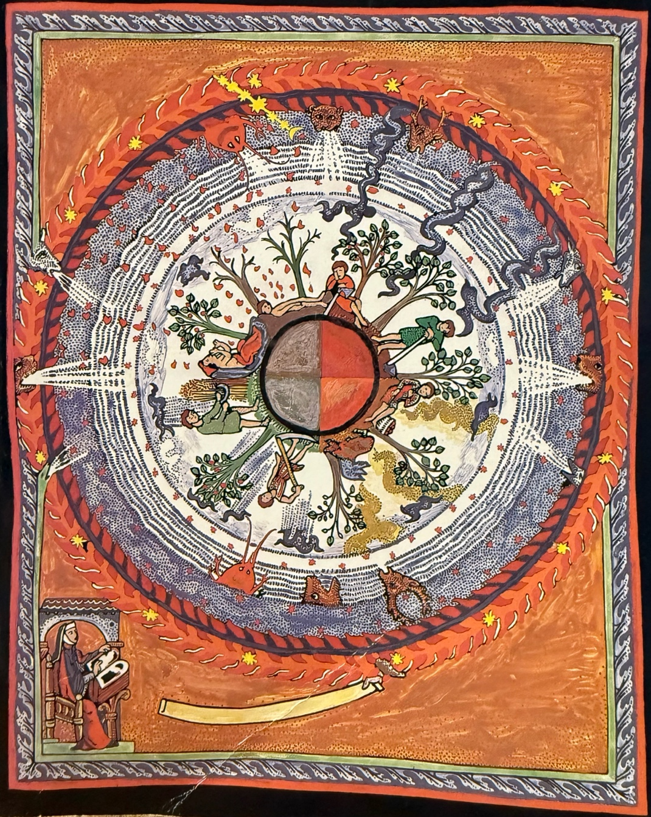

I was reminded of some photos I took of the stunning fall we have here in Estes, and I thought I’d share as not everyone can access nature as easily as I am able to do. They don’t really capture the full impact but they give you an idea anyway!
